Module 8: How to Facilitate Workshop 7
Debt & Tools to Get Out of It

Part 1: Introduction to Workshop 7
Welcome back to MHAAO’s Money Basics Facilitator Training!

In this Module, you will learn how to facilitate Workshop 7, which explores different methods for paying off debt.

This workshop begins by focusing on how to calculate personal debt. After this, participants will learn about different tools and strategies for paying off debts, including creating an Action Plan for getting out of debt.

The advanced preparations for Workshop 7 are located in the Facilitator Guide, which will also provide time estimates for each topic and page numbers that correspond to the Student Guide for the topics.

There are a number of useful videos for debt calculation and payment options located in the Facilitator Toolkit.

As always, you will begin each class by welcoming back the participants, facilitating a quick check-in about how their homework assignments went, reviewing the Community Agreements, and providing students with a quick overview of the agenda for that workshop.

Let students know that this class is centered around calculating and paying off debt. Many of the participants will likely have some lived experience with debt and how overwhelming and hopeless getting out of debt can feel.

It is important to center this class around hope. Having debt is nothing to be ashamed of and getting out of debt is possible.

Part 2: Thoughts on Debt
You will begin this workshop by asking the participants to spend a few minutes writing down in their Student Guides or Workshop 7 Worksheets their responses to the question: When you think about debt, what kinds of feelings does this evoke for you?
After a few minutes, ask the participants to think about and write down their responses to the questions: How would you like to feel about debt? Where would you like to be in one year? In three?
Facilitators should do this activity as well. After about 5 minutes, you’ll come back together for a group discussion. If comfortable, ask the participants to share any thoughts or feelings that came up that they feel comfortable sharing, writing down their responses on the whiteboard. Facilitators should share as well.
Zoom Tip: Use Google’s Jam Board feature. Participants can write their responses to these questions anonymously on virtual post-it notes on the Jam Board. Facilitators can read off the responses when everyone is finished. Jam Board is a great way to make virtual discussions more collaborative, and anonymity can help participants who may usually not be comfortable sharing out loud be more involved in the discussion.
After this, you can facilitate a quick discussion on the ways debt can affect a person’s mental health and wellbeing, asking the participants to brainstorm ways that debt can impact a person’s stress levels, relationships, self-worth, etc. Emphasize that the focus of this class is on hope and a debt-free future.
Part 3: Calculating Personal Debt & Debt to Income Ratios
On pages 119 to 120 of the Student Guide, there are steps for gathering all of one’s debts and creating a list of each one, its interest rate, its minimum payment, and how much is owed. At the end of Workshop 6, you will ask the participants to complete this activity and worksheet as homework, and bring their completed list of current debts to this class. If facilitators have personal debts and would benefit from this activity, they are encouraged to complete this worksheet as homework as well.
This list will help participants calculate their debt-to-income ratios and complete their debt pay-off PDPs, and will be relevant to the section on debt payment strategies.
Using the steps in the Student Guide, you will help participants calculate their Debt-to-Income Ratios.
A person’s debt to income ratio measures their ability to make current debt payments. This can be achieved by dividing their debt payments by their take-home pay. This number helps us consider how much one’s monthly debt is compared to their monthly income. Ideally, a person’s minimum monthly debt should be no greater than 36% of their income.
To calculate their debt-to-income ratios, ask the participants to complete the following steps:
Step 1: Calculate your monthly debt.
Step 2: Add up your total gross monthly income. Gross income is the amount you receive before taxes or deductions are taken out. It can include wages, tips, benefits, alimony, business income, capital gains, dividends, CD account interest, pension, and more.
Step 3: Divide your total monthly debt amount by your total gross income.

Monthly debt: | $
Monthly income: | $
Debt to income ratio: | ____%
^ Include this table in the Vyond animation
Facilitators should do the activity with participants and be available to answer questions. Participants can complete the activity in the space provided in their Student Guides, Workshop 7 Worksheets, or in notebooks or scratch paper.
Once everyone is finished, invite a group discussion, if participants feel comfortable, and open the space up for questions.
Part 5: How to Go Over Different Options for Paying off Debts
For this section, you can begin by writing down the following list of debt payment strategies on the whiteboard, leaving enough space to add notes: 1) long-term strategy, 2) interest rate strategy, and 3) month-to-month strategy.
Go over each of these strategies for organizing and paying off debts, discussing the pros and cons of each.
The long-term strategy is when a person organizes their debts by which one will cost more throughout the length of the debt and works their way from most expensive to least expensive.
The interest rate strategy is when a person orders their debts by their interest rate, with the highest rates as the top priority, and pays off debts with the highest interest first, then moves on to bills with lower interest rates.
The month-to-month strategy is when a person lists all of their monthly bills by the ease of payoff. This could mean the smallest amount they owe, or the debt with the shortest term until it is paid in full. After they get one debt paid off, they move on to the next, and so on until they get their monthly budget under control. This strategy is usually a short-term fix for what are likely longer-term financial problems.
After this discussion, add the snowball technique and avalanche technique to the list on the whiteboard and explain how these techniques work:
With the Snowball Technique: You will list your debts in order from lowest balance to largest. Don’t pay attention to interest rates. Put extra money towards your smallest debt, while continuing to make minimum payments on all your other debts, and work your way up. Once you’ve paid the smallest debt off, move on to the next smallest, and so on, working your way through your list.
The advantages of this technique are that it produces fast results on your small debts, which can build momentum and motivation to stick with your debt pay-off plan. It can also be easier to implement than the avalanche technique. The disadvantages are that this method can be more expensive in the long run (because you continue to incur interest) and can take longer to become completely debt-free.
With the Avalanche Technique: You will list your debts in order from the highest interest rate to the lowest. Don’t pay attention to the balance. Put extra money toward the debt with the highest interest rate, while continuing to make minimum payments on your other debts. You will start at the top and work your way down, focusing on the next-highest interest rate, and so on.
The major advantages of this technique are that it can save you lots of money in the long run by reducing the amount you pay in interest, and can help you to pay off large amounts of debt relatively quickly. However, the disadvantages are that it requires a lot of discipline and a steady income to make these additional payments each month.
Emphasize how both methods are fantastic ways to pay off debts relatively easily and quickly. Generally, the best method is the one a person thinks they can realistically stick with, depending on their unique financial situation and personality.
After this, go over the tips for short-term debt payoff, which are:
- Make paying off debts part of your budget
- Pay off the highest interest debt first
- Do not accumulate more debt
- For past due bills or debt payments, call the creditors and settle on a payment plan. They will work with you and are accustomed to people asking for leniency
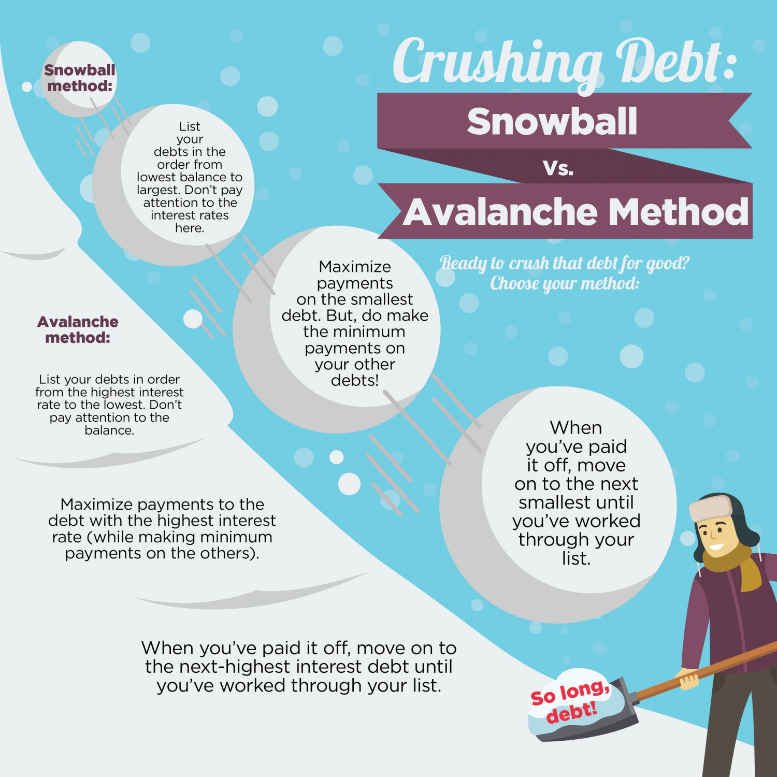
Invite questions and comments and consider using example scenarios to illustrate the impact these different strategies could have on reducing debt.
Highlight the online resources in the Student Guide for calculating how long it will take to pay off a debt. You could pull up one or two debt-calculation websites on the screen as an example.
There are some helpful videos in the Facilitator Toolkit on different ways to get out of debt, including the differences between the “snowball technique” and “avalanche technique.” Including video content may be a useful way to break up this section and engage the participants.
Part 6: Going Over Additional Debt Payoff Options
Next, you will go over additional payment options for paying off debt, and the pros and cons of each. Save bankruptcy for the end.
Encourage the participants to offer their own pros and cons and any comments, questions, or personal experiences, if they feel comfortable sharing.
These additional options are:
Option 1: Debt consolidation. With debt consolidation, you merge multiple bills into one consolidated loan. The lender pays off your existing debt and you make one payment to the lender.
Option 2: Debt management plan. With a debt management plan, a financial counselor from a nonprofit credit counseling agency helps set up an agreement with your creditor. You make one payment to the nonprofit agency and they disperse the money to your creditors. This is similar to debt consolidation but does not require a loan.
Option 3: Getting a second loan. With this option, you would take out a new loan to pay off an old one. This is usually done to address an urgent need.
Option 4: Credit counseling. Working with a credit counselor can help you negotiate payments, late fees, interest rates, and more with your creditor.
Option 5: Debt settlement. This option involves negotiating with a creditor to reduce the amount you owe. You pay a lump-sum payment to the creditor in exchange for them forgiving a portion of the debt you’ve accumulated.
Option 6: File for Bankruptcy. This is a final, last result option. When you file for bankruptcy, a judge and a court trustee examine the assets and liabilities of individuals whose debts have become too overwhelming to be able to pay them. The court decides whether to discharge the debts so the individual is no longer required to pay them, or dismiss the case if they believe the person has enough assets to pay what they owe. Emphasize that a person should try all other options before filing for bankruptcy.
As a class, you will go over the pros and cons of bankruptcy, using the information in the Student Guide and any personal knowledge or experiences. Bankruptcy is a last resort option and can affect a person’s finances for years to come.
Please note: There is an option for facilitators to do research on bankruptcy laws in your state before the start of class. If this is something you do not have the time to do or do not think the participants will benefit from, you can stick to discussing the information on bankruptcy in the Student Guide and the definitions in the Glossary for Bankruptcy Chapters 7, 11, and 13.
Part 7: How to Help Participants Create a PDP for Getting out of Debt
In this section, you will ask participants to create an Action Plan for getting out of debt, using the Workshop 7 Worksheets. Before beginning the process, you may choose to ask participants to pull up their Financial Person Directed Plans from Workshop 2 to use as a reference for this exercise.
Ask the participants to complete their person-directed plans individually or in pairs. Facilitators should be available to help participants with their worksheets and can do this activity as well if they would find it useful.
Part 8: Wrap Up
Like every workshop, you can wrap up the class by allowing space for questions and comments and by reviewing the homework assignments. You are encouraged to fill out the “Facilitator Reflection” form at the end of every class and meet up with your co-facilitator to plan for the next class.
Congratulations, you’ve completed Module 8 of the Money Basics Facilitator Training! Before you continue with your day, please complete the review questions and check out the homework assignments.

